LAB No 13
Explore the Linux File System Hierarchy
In this lab, students will explore the Linux file system hierarchy to understand the purpose and structure of key directories such as /, /home, /etc, /bin, and /var. Students will navigate the file system using basic Linux commands and observe how files and directories are organized. By the end of the lab, students will be able to explain the role of major directories in a Linux system and locate common system and user files.

LAB Task 1:
- Open the terminal.
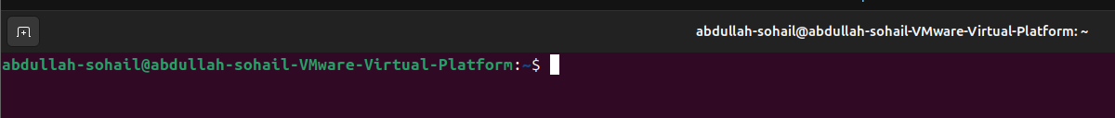
- Type the following command to see your current directory:

Pwd

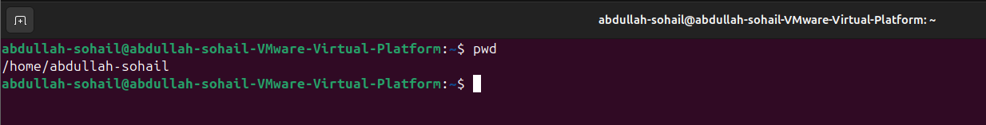
- List the contents of the current directory:

Ls

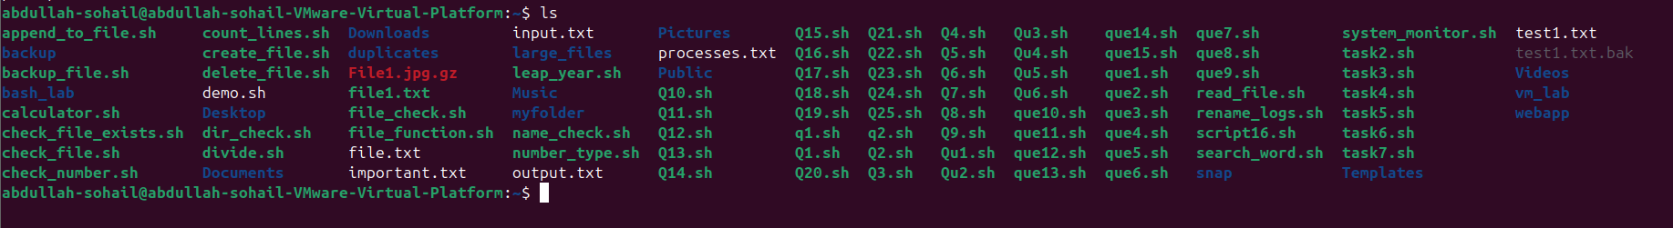
- Explore the root (/) directory:

cd / ls -l

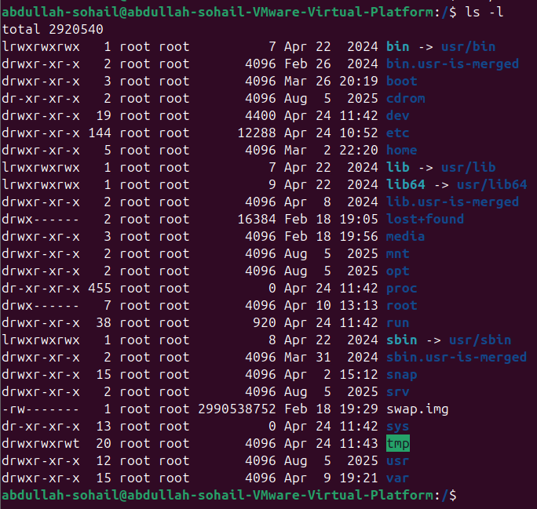
- Observe the main directories and note their purposes:

Directory | Purpose
/ | Root directory (top of the file system)
/bin | Essential user binaries
/sbin | System binaries (for root)
/etc | Configuration files
/var | Variable files (logs, mail, cache)
/usr | User programs and libraries
/home | User home directories
/tmp | Temporary files

Directory | Purpose
/boot | Boot loader and kernel files
- Navigate inside /etc, /var, and /home to see their contents.
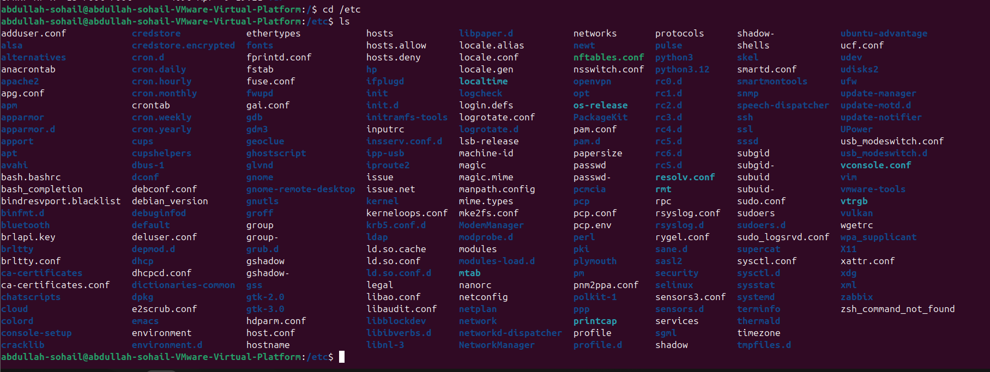
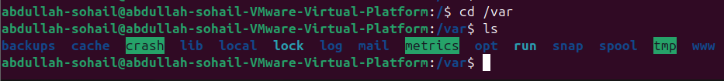
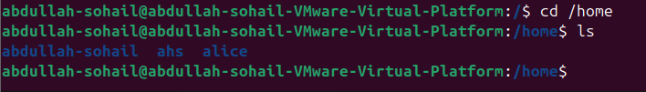

LAB Task 2: Work with Files and Directories
- Go to your home directory:
cd ~
- Create a directory named practice:
mkdir practice
- Move inside that directory:
cd practice
- Create files using different commands:
touch file1.txt
echo "Welcome to Linux Lab" > file2.txt
- nano file3.txt # Add some text manually, then save with Ctrl+O, exit with Ctrl+X
- View the files:
ls -l
cat file2.txt
- Copy and move files:
cp file1.txt backup.txt mv file3.txt notes.txt
- Delete files and directories: rm backup.txt
- cd ..
rmdir practice
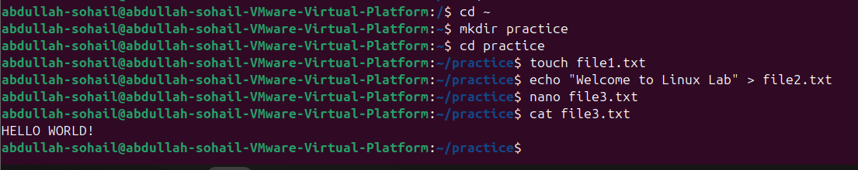
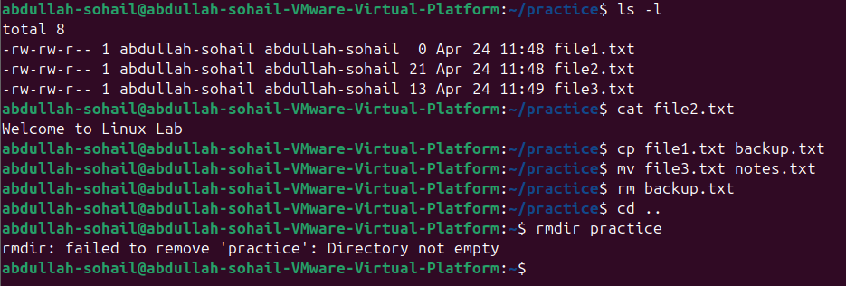

Task 3: Explore Hidden Files and Directories

- List all files including hidden ones:
ls -a
- Observe files starting with . — e.g., .bashrc, .profile.
  - These are hidden configuration files.
- View contents of .bashrc:
cat ~/.bashrc
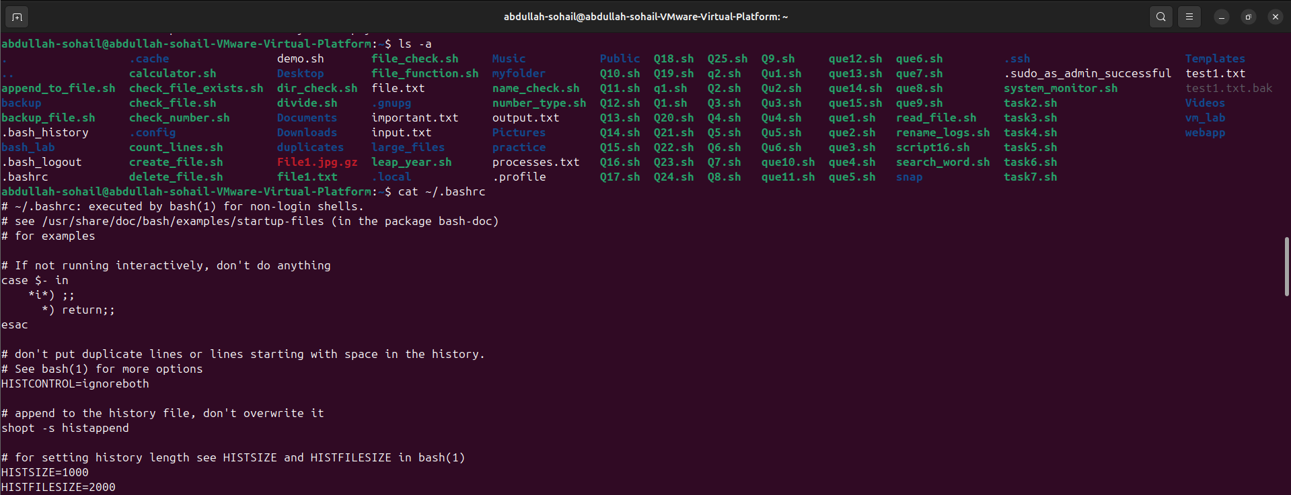

Task 4: Understanding Privilege Levels
- Check the current user:
whoami
- Try creating a file in /root:
cd /root touch test.txt
You should see a “Permission denied” message because you’re a normal user.
- Switch to root (if permitted):
sudo su
or use sudo before the command:
sudo touch /root/test.txt
- Check the difference between permissions: ls -l /root
- Exit root mode:
Exit
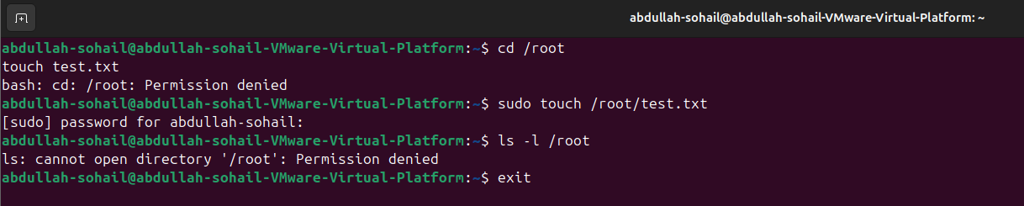

Task 5: File and Directory Permissions
- Create a test file: touch perm.txt
ls -l perm.txt
- Change permissions:
chmod 744 perm.txt ls -l perm.txt
  - Owner: read, write, execute
  - Group: read only
  - Others: read only
- Change file ownership (only with sudo): sudo chown root perm.txt
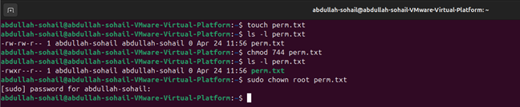

Task 6: Summary Commands to Try Command Purpose
pwd Print working directory ls, ls -l, ls -a List directory contents cd, cd .., cd ~ Change directories
mkdir, rmdir Create/remove directories cp, mv, rm Copy, move, remove files cat, more, less View file content
chmod, chown Change permissions or ownership sudo Run command with root privileges man <command> View manual/help

Lab Report Format
Each student must include in their report:

Objective
  - Commands used
  - Screenshots of terminal outputs showing:

    - Navigating directories
    - Creating and modifying files
    - Using sudo and permission commands

